# Story-board for filling out a death certificate

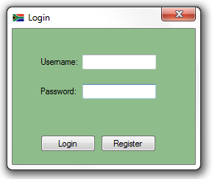1:User must insert valid login Details

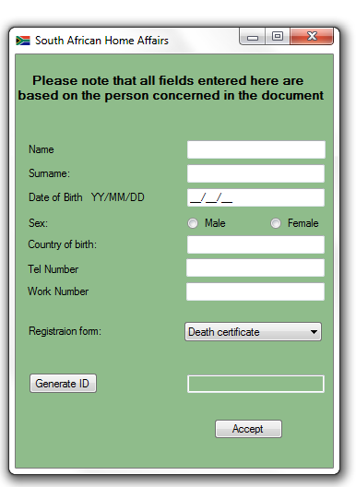3: user must insert the particulars of the person of interest

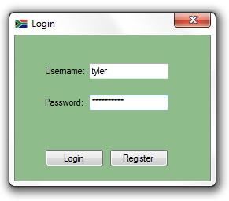2:Once Valid user details are inserted user must login

4:Once the user has entered all the relevant information 5:User Selected death certificate, once again

They must select a registration forn via the combobox and user must fill out the necessary information

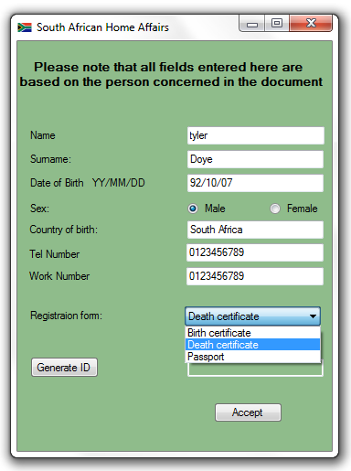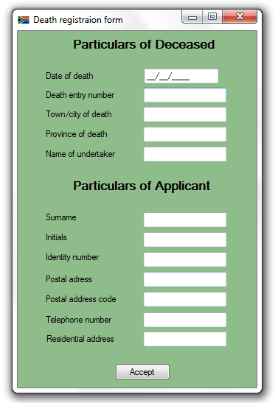 Click accept

6:After the user completes the registration form User is show the final report of all their

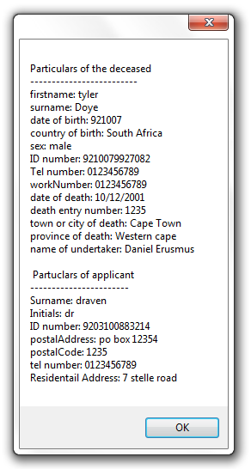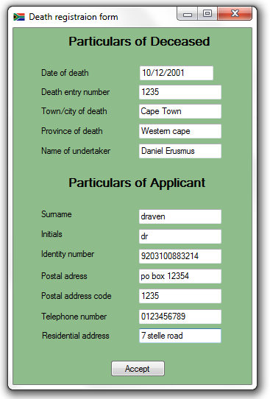they must click accept information